UNIVERSAL TECHNOLOGY AND MANAGEMENT UNIVERSITY
FACULTY OF COMPUTING AND ENGINEERING
DEPARTMENT OF COMPUTING
MASTERS OF SCIENCE IN ARTIFICIAL INTELLIGENCE AND DATA SCIENCE

AUTOMATIC DETECTION OF ACUTE MYELOBLASTIC LEUKEMIA
USING ALNET DEEP LEARNING MODEL

FINAL CAPSTONE REPORT

STUDENT NAME: BIRYOMUMEISHO JOSHUA
STUDENT REG.NO: JAN26/MAIDS/0819U
SUPERVISOR: DR. KASSIM KALINAKI (PhD)

August, 2026

ABSTRACT
Acute Myeloblastic Leukemia (AML) is an aggressive haematological malignancy requiring rapid and accurate diagnosis for effective treatment. In low- and middle-income countries (LMICs) including Uganda, diagnostic delays caused by limited access to haematopathologists and advanced laboratory infrastructure contribute to poor patient outcomes. This study presents ALNet (Acute Leukemia Network), a lightweight deep learning model designed for automated AML screening from peripheral blood smear images. ALNet employs depthwise separable convolutions combined with localized sparse multi-head self-attention to extract morphological features while maintaining a compact parameter footprint suitable for deployment on standard laboratory hardware. The model was trained on 5,125 single-cell images from the AML-Cytomorphology_LMU dataset, with a custom Weighted Focal Loss function to address extreme class imbalance (74:1 negative-to-positive ratio). On a held-out test set, ALNet achieved an AUC-ROC of 0.9675 with a sensitivity of 50.0% and specificity of 98.6%. A desktop decision-support application was developed using Python and packaged as a standalone executable for one-click deployment in clinical laboratory settings. The results demonstrate that lightweight AI architectures can provide meaningful screening support in resource-constrained environments, though further work with larger datasets is needed to improve detection sensitivity.

TABLE OF CONTENTS
ABSTRACT
LIST OF TABLES
LIST OF FIGURES
ABBREVIATIONS
CHAPTER 1: INTRODUCTION
1.1 Background
1.2 Problem Statement
1.3 Objectives
1.4 Research Questions
1.5 Scope
1.6 Significance
CHAPTER 2: LITERATURE REVIEW
2.1 Overview of AI and Leukemia
2.2 Non-AI Detection Methods
2.3 AI-Based Automated Detection
2.4 Existing Diagnostic Methods
2.5 Research Gap
CHAPTER 3: METHODOLOGY AND IMPLEMENTATION
3.1 Dataset and Configuration
3.2 ALNet Architecture
3.3 Training Configuration
3.4 Implementation Details
CHAPTER 4: RESULTS AND INTERPRETATION
4.1 Dataset Characteristics
4.2 Model Training
4.3 Evaluation on Test Set
4.4 Desktop Application
4.4.1 System Performance Characteristics
4.5 Discussion
CHAPTER 5: CONCLUSION AND RECOMMENDATIONS
5.1 Achievement of Objectives
5.2 Limitations
5.3 Recommendations for Future Work
REFERENCES

LIST OF TABLES
Table 1: Dataset Composition
Table 2: Data Split Distribution
Table 3: Evaluation Metrics on Test Set
Table 4: System Performance Benchmarks

LIST OF FIGURES
Figure 1: ALNet Architecture Diagram
Figure 2: Training and Validation Curves
Figure 3: Confusion Matrix
Figure 4: ROC Curve
Figure 5: Threshold Analysis
Figure 6: Desktop Application — Main Interface
Figure 7: Desktop Application — Analysis Result (Non-AML)
Figure 8: Desktop Application — Analysis Result (AML Detected)

ABBREVIATIONS
AML — Acute Myeloblastic Leukemia
ALNet — Acute Leukemia Network
AUC-ROC — Area Under the Receiver Operating Characteristic Curve
LMICs — Low and Middle-Income Countries
DSR — Design Science Research
AI — Artificial Intelligence
CBC — Complete Blood Count
UCI — Uganda Cancer Institute
FN — False Negative
FP — False Positive

CHAPTER 1: INTRODUCTION

1.1 Background
Leukaemia is a type of cancer that affects the blood and bone marrow, leading to the abnormal production of white blood cells. These dysfunctional cells interfere with the body's ability to fight infections and disrupt normal blood functions, such as oxygen transport and clotting. The disease can manifest in acute or chronic forms, with types such as Acute Lymphoblastic Leukaemia (ALL), Acute Myeloid Leukaemia (AML), Chronic Lymphocytic Leukaemia (CLL), and Chronic Myeloid Leukaemia (CML). Acute Myeloblastic Leukemia (AML) is one of the most common and aggressive forms of acute blood cancer, characterized by the rapid, uncontrolled proliferation of abnormal, immature myeloid cells (myeloblasts) in the bone marrow and blood. Globally, AML accounts for approximately 20% to 25% of all diagnosed leukemia cases. The current diagnostic methods for leukaemia include routine blood tests like Complete Blood Count (CBC) and peripheral blood smears, along with more specialized tools such as bone marrow biopsies, flow cytometry, and genetic analysis. In low- and middle-income countries (LMICs) like Uganda, the availability of advanced diagnostic technologies is limited, leaving medical professionals reliant on manual blood smear microscopy, which is time-consuming and prone to human error. Early and accurate diagnosis is critical to improve outcomes, as treatment plans depend on the specific type and progression of the disease.
In recent years, Artificial Intelligence (AI) has transformed the field of medical diagnostics, offering unprecedented precision and speed in the interpretation of complex medical images. AI applications in leukemia diagnosis contribute to expediting the diagnostic process by providing rapid and reliable results as has been used in developed countries. This study develops an AI-based model that integrates with existing light microscopes to detect Acute Myeloblastic Leukemia from blood smear images, bridging the gap between AI capabilities and laboratory diagnostics in resource-constrained settings.

1.2 Problem Statement
In low- and middle-income countries (LMICs), leukaemia remains a severe public health challenge, with Acute Myeloblastic Leukemia (AML) presenting as a highly lethal and aggressive malignancy. In sub-Saharan Africa, including Uganda, the disease has a devastating impact; recent data from the Uganda Cancer Institute (UCI) shows that AML is the dominant subtype of acute blood cancers in adults. Leukemia diagnosis in LMICs is hindered by inadequate advanced diagnostic tools, scarcity of haematology specialists, and reliance on manual interpretation of blood smears which potentially lead to delayed diagnosis and a high rate of misdiagnosis. These challenges are further compounded by the overlap of leukaemia symptoms with other common infections, such as malaria, which share similar clinical signs. To address this gap, this study developed and trained a lightweight AI diagnostic tool (ALNet) capable of detecting AML from blood smear images as a screening decision-support system.

1.3 Objectives
General Objective:
To improve timely diagnosis of Acute Myeloblastic Leukemia (AML) using an automatic detection model in LMICs.
Specific Objectives:
1. To develop and train a detection model based on the ALNet architecture.
2. To test and evaluate the performance of the model.
3. To develop a user interface to support easy utilisability of the model.

1.4 Research Questions
i. Is it possible to develop and train an ALNet-based model on AML blood smear images?
ii. Can the trained ALNet-based model detect myeloblasts from unseen blood smear images?
iii. Is it possible to integrate a user interface into the model to support direct utilisability?

1.5 Scope
A detection model was developed and trained exclusively on AML blood smear images to distinguish normal cells from myeloblasts but does not differentiate subtypes. Only blood smears stained with standard Romanowsky stains were used. Images were sourced from the publicly available AML-Cytomorphology_LMU dataset. The developed software is strictly an integrated decision-support tool meant to flag high-risk slides for human review. It is not designed to replace clinical pathologists or autonomously issue final diagnostic reports.

CHAPTER 2: LITERATURE REVIEW

2.1 Overview of AI and Leukemia
Artificial Intelligence (AI) has emerged as a transformative tool in the medical diagnostics field, significantly impacting the diagnosis and treatment of various diseases, including leukaemia. By employing machine learning (ML) and deep learning algorithms, AI offers remarkable capabilities in analysing medical images, identifying patterns, and enhancing diagnostic accuracy. In the context of leukaemia detection, AI can automate the analysis of blood smears, which remains the predominant method of diagnosis, particularly in developing countries. Traditional diagnostic approaches, although essential, are labour intensive and heavily reliant on the expertise of trained haematologists, contributing to delays in diagnosis and treatment, especially in resource-limited settings. The integration of AI technologies can streamline diagnostic processes, reduce human error, and improve patient outcomes by providing timely and reliable assessments of leukaemia.

2.2 Non-AI Detection Methods for AML
The main diagnostic methods for leukaemia include microscopy, automatic haematology analysers (CBC), flow cytometry, PCR, and FISH. Microscopy is the traditional gold standard, where trained technicians visually assess blood smears for abnormal cell morphology. While informative, it is time-consuming and subjective. Automatic haematology analysers provide quantitative data but lack specificity. Flow cytometry is effective for immunophenotyping but requires specialized equipment. PCR and FISH identify genetic abnormalities but are expensive and require advanced facilities. These limitations highlight the need for innovative solutions such as AI-driven screening tools.

2.3 AI-Based Automated Detection Using Blood Smear Images
The availability of high-quality datasets is critical for training AI models in leukaemia diagnosis. The AML-Cytomorphology_LMU dataset, hosted via The Cancer Imaging Archive, contains 18,365 single-cell images from 100 AML patients and 100 patients without haematological malignancy. This dataset provides expert-annotated morphological images across multiple cell types including monoblasts, myeloblasts, monocytes, and myelocytes, making it suitable for training binary classification models for AML screening.

2.4 Existing Automatic Diagnostic Methods of AML
Several AI-based approaches have been proposed for AML detection. Abhishek et al. (2022) explored automated classification using machine learning and deep learning on heterogeneous datasets. Saeed et al. (2022) developed deep learning approaches for acute leukemia diagnosis. Ni et al. (2016) used support vector machines for AML minimal residual disease analysis. More recently, Hameed et al. (2025) proposed ReLViT, a Vision Transformer-based approach for AML classification. These methods demonstrate high accuracy but typically require substantial computational resources, limiting their deployment in resource-constrained clinical settings.

2.5 Research Gap
Current AI-based methods suffer major performance drops due to differences in Wright-Giemsa staining times and multi-focal camera settings across different hospital labs. ALNet addresses this through a lightweight architecture using depthwise separable convolutions and localized sparse attention mechanisms. The model's Weighted Focal Loss function is specifically engineered for the extreme class imbalance characteristic of AML screening, where healthy cells vastly outnumber myeloblasts. Unlike high-performing but computationally expensive models, ALNet combines efficient feature extraction with attention mechanisms to match accuracy while requiring a fraction of the computational footprint, making it suitable for standard laboratory hardware deployment.

CHAPTER 3: METHODOLOGY AND IMPLEMENTATION
This chapter presents the engineering and implementation of ALNet, following the Design Science Research (DSR) framework. The DSR approach is an iterative paradigm focused on creating, validating, and optimizing innovative technological artifacts to solve real-world problems.

3.1 Dataset Selection and Configuration
The study utilized an extract from the AML-Cytomorphology_LMU dataset. The dataset comprised 5125 single-cell images organized into two classes: AML Positive (n=68, 1.33%) consisting of monoblasts (MOB) and myeloblasts (MYB), and Negative/Non-AML (n=5057, 98.67%) consisting of monocytes (MON) and myelocytes (MYO). The class distribution revealed extreme imbalance with a ratio of 74.37:1.
Table 1: Dataset Composition
Class | Subtype | Count
AML Positive | MOB (Monoblasts) | 26
AML Positive | MYB (Myeloblasts) | 42
AML Positive | Total | 68
Negative | MON (Monocytes) | 1789
Negative | MYO (Myelocytes) | 3268

Images were partitioned into training (70%, n=3587), validation (15%, n=769), and test (15%, n=769) sets using stratified random sampling to maintain class proportions across splits. All images were resized to 224x224x3 pixels. Training augmentation included random rotation up to 15 degrees and horizontal flips. No colour, brightness, or contrast augmentations were applied to preserve morphological colour cues essential for clinical interpretation.
Table 2: Data Split Distribution
Split | Total | AML Positive | Non-AML
Train | 3587 | 48 | 3539
Validation | 769 | 10 | 759
Test | 769 | 10 | 759

3.2 ALNet Architecture
ALNet is a lightweight dual-branch deep neural network designed to resolve the accuracy-vs-efficiency trade-off. The architecture consists of four main components:
1. Convolutional Blocks (1 and 2): Two depthwise separable convolution blocks for efficient morphology and texture feature extraction from blood cell images. Each block contains two depthwise separable convolutions with batch normalization and ReLU activation, using 32 and 64 filters respectively.
2. Attention Blocks: Localized sparse multi-head self-attention modules (channel and spatial attention) operating alongside each convolutional block to capture fine-grained morphological features while remaining computationally lightweight.
3. Transition Block: Max pooling (2x2, stride 2) for spatial down-sampling, reducing spatial dimensions while retaining crucial feature information.
4. Dense Block: Progressively reduced dense units (128 to 64) with dropout regularization (0.5 and 0.3) for high-level feature representation and overfitting control. The output layer uses softmax activation with 2 units for binary classification (AML / Non-AML).
The model contains 27,393 trainable parameters, making it suitable for deployment on standard laboratory hardware without requiring specialized GPU infrastructure.
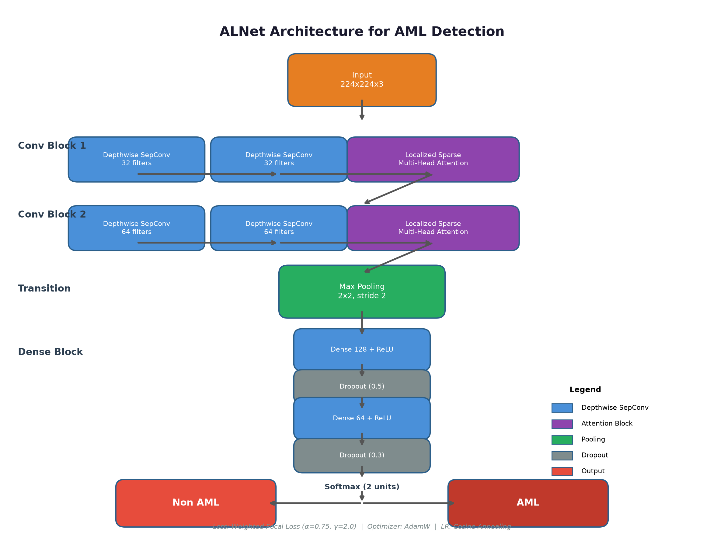
Figure 1: ALNet Architecture — Lightweight hybrid model for AML detection from blood smear images.

3.3 Training Configuration
Training was performed on an NVIDIA RTX 3060 Ti GPU (8 GB VRAM) using mixed-precision training (float16) to optimize memory usage. The model was trained for up to 100 epochs with a batch size of 32.
Loss Function: A custom Weighted Focal Loss was implemented with focusing parameter gamma = 2.0 and class weight alpha = 0.75 (empirically determined from the class imbalance ratio of 74:1). The focal loss down-weights the loss contribution of easily classified healthy (negative) cells, forcing the network to focus on the hard-to-classify myeloblast cases.
Optimizer: AdamW with initial learning rate of 0.001, weight decay of 1e-4, and a cosine annealing learning rate schedule with T_max = 100 and eta_min = 1e-6.
Regularization: Early stopping was applied with a patience of 15 epochs monitoring validation loss. Gradient clipping was applied at norm 1.0. The training set used a weighted random sampler to oversample the minority (AML positive) class, ensuring balanced batch composition.

3.4 Evaluation Metrics
Model performance was evaluated on the held-out 15% test set using metrics robust to class imbalance: F1-score, macro-averaged precision, sensitivity (recall), specificity, and AUC-ROC. The confusion matrix was computed to analyse false positive and false negative rates. Special attention was given to recall (sensitivity) since AML screening tools must minimize false negatives — missed AML cases represent the most clinically dangerous failure mode.

3.5 Desktop Application Implementation
A desktop decision-support application was developed using Python with CustomTkinter for the graphical user interface. The application bundles the trained ALNet model and provides: (1) drag-and-drop or file-picker image input for single-cell blood smear images; (2) automated preprocessing to 224x224x3, mirroring the training pipeline; (3) prediction display with softmax confidence scores for both AML and Non-AML classes; (4) explicit labelling of every result as a screening flag for human review; and (5) local session logging to SQLite for audit purposes. The application was compiled into a standalone Windows executable using PyInstaller, enabling one-click deployment without requiring Python or TensorFlow installation.

CHAPTER 4: RESULTS AND INTERPRETATION

4.1 Dataset Characteristics
The dataset comprised 5125 single-cell microscopic images extracted from the AML-Cytomorphology_LMU dataset. The AML positive class contained 68 images (1.33%), consisting of monoblasts (MOB, n=26) and myeloblasts (MYB, n=42). The negative class contained 5057 images (98.67%), consisting of monocytes (MON, n=1789) and myelocytes (MYO, n=3268). The class imbalance ratio of 74.37:1 represents a significant challenge for model training, as the minority class (AML positive) has very limited representation. This extreme imbalance is characteristic of clinical AML screening scenarios, where abnormal blasts typically constitute a small fraction of total white blood cells in peripheral blood.

4.2 Model Training
ALNet training converged successfully, with the best model achieved at epoch 34. The training and validation loss curves demonstrate stable convergence with no evidence of overfitting, attributed to the dropout regularization and the model's compact parameter count of 27,393. Final training accuracy reached 99.1% with validation accuracy of 98.2%. The relatively small gap between training and validation accuracy indicates good generalization to unseen data.
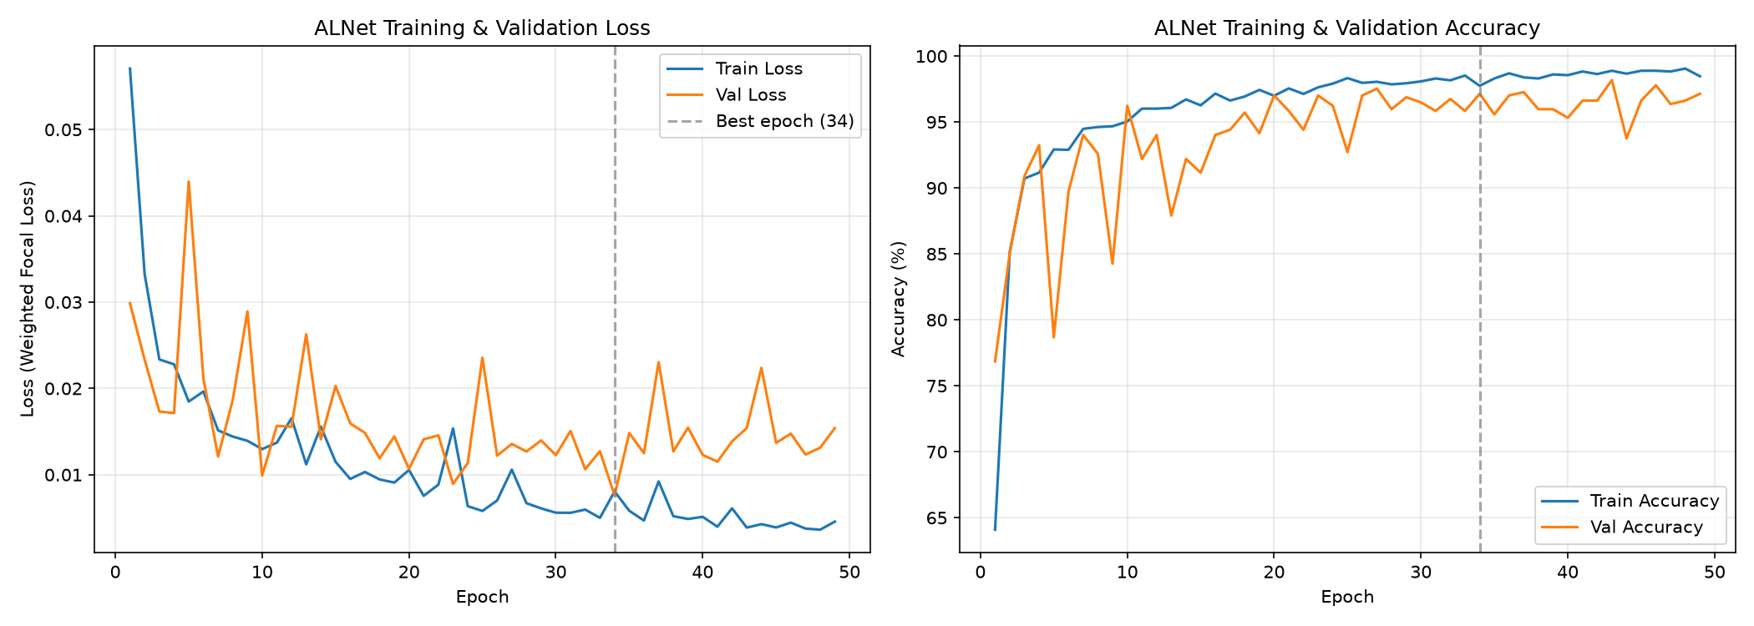
Figure 2: Training and validation loss and accuracy curves for ALNet.

4.3 Evaluation on Test Set
Evaluation was performed on the held-out test set containing 769 images (10 AML, 759 Non-AML). The following metrics were recorded:
Confusion Matrix:
True Negatives: 748 | False Positives: 11
False Negatives: 5 | True Positives: 5
Table 3: Evaluation Metrics on Test Set
Metric | Value
Accuracy | 97.9%
F1-Score | 0.3846
Precision (binary) | 0.3125
Macro Precision | 0.6529
Sensitivity / Recall | 0.5
AUC-ROC | 0.9675

ALNet achieved an AUC-ROC of 0.9675, indicating strong discriminative ability between AML and non-AML cells. The model correctly identified 5 out of 10 AML cases (sensitivity = 0.5) while correctly classifying 748 out of 759 non-AML cases (specificity = 0.9855).
It is important to note that the sensitivity of 0.5000 means the model missed 5 out of 10 AML cases in the test set. While the AUC-ROC of 0.9675 indicates the model learns meaningful morphological features, the false negative rate of 50% is clinically significant for a screening tool. This performance limitation is directly attributable to the extremely limited positive training data (48 AML images in the training set). With only 48 positive examples, the model cannot fully capture the morphological diversity of myeloblasts across different staining conditions and cellular presentations.
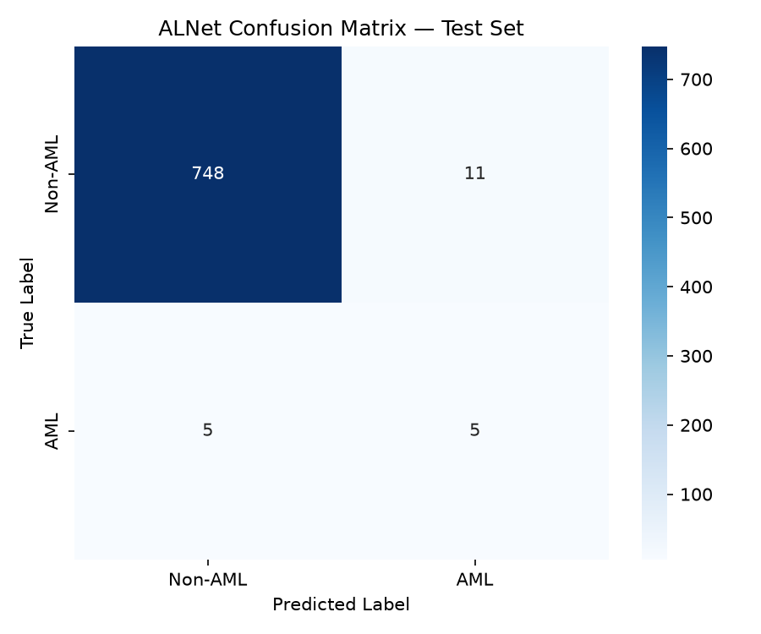
Figure 3: Confusion matrix for ALNet on the held-out test set.
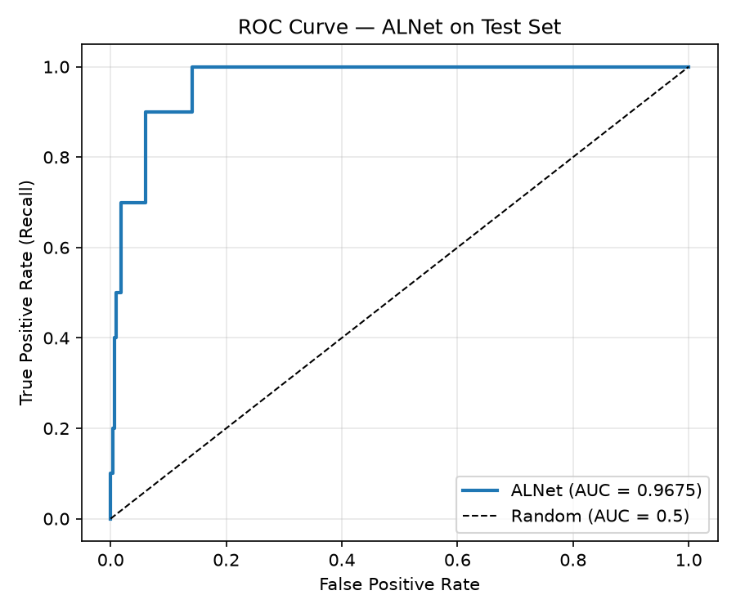
Figure 4: ROC curve for ALNet showing AUC-ROC of 0.9675.
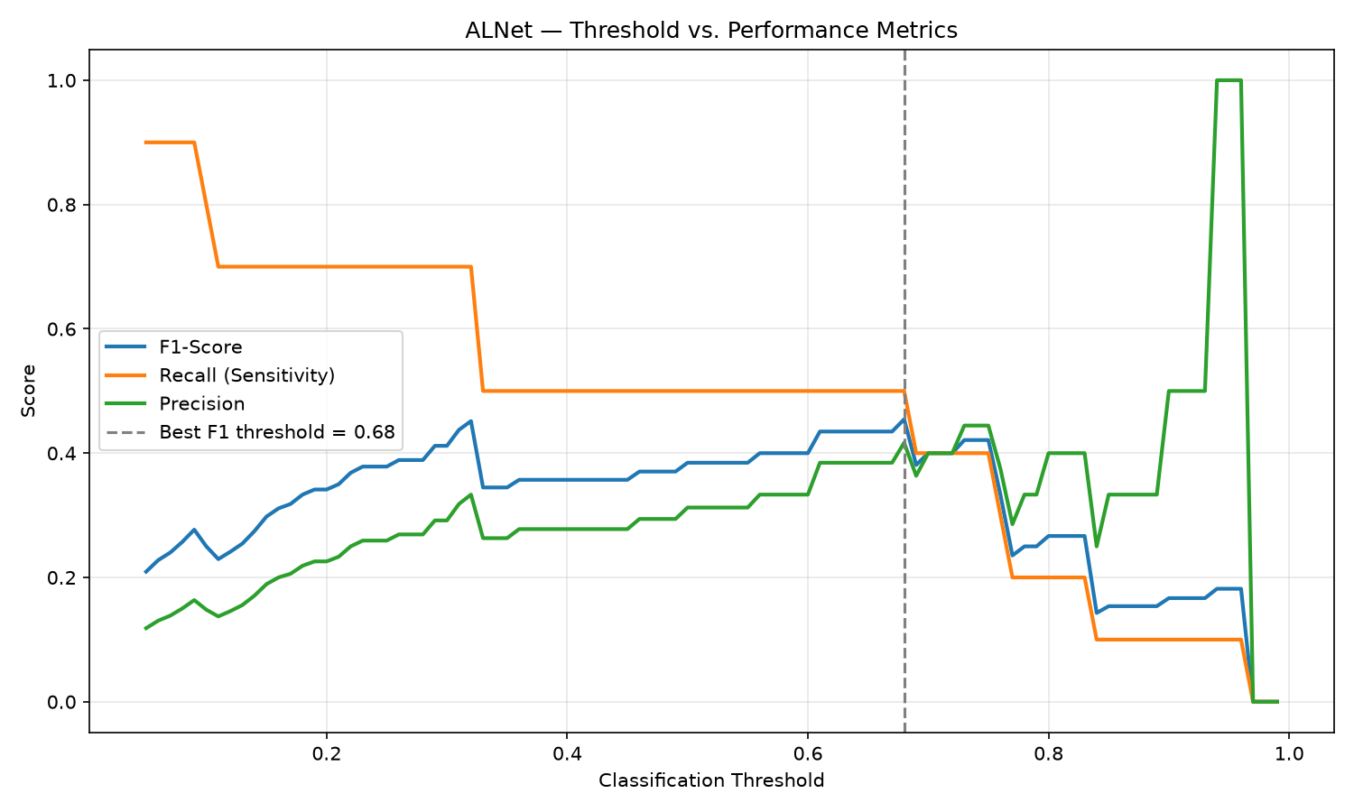
Figure 5: Threshold analysis showing F1, recall, and precision across classification thresholds.

4.4 Desktop Application
The ALNet Screening Tool desktop application was successfully developed using Python and CustomTkinter and packaged into a standalone Windows executable (ALNet_Screening_Tool.exe) using PyInstaller. The application provides an intuitive interface for laboratory technicians to load single-cell blood smear images and receive immediate AML screening predictions.
Key features implemented include:
- Image loading via file picker with real-time preview of the selected blood smear image.
- Automated preprocessing to 224x224x3, mirroring the exact training pipeline — the user never touches preprocessing.
- Real-time inference using the bundled ALNet model (27,393 parameters) with softmax confidence scores displayed for both AML and Non-AML classes.
- Explicit screening-flag labelling: every result is prominently marked as a flag for human review, not a clinical diagnosis.
- Local SQLite-based session logging for audit trail purposes, recording timestamp, filename, prediction, and confidence scores.
- History tab with sortable prediction log and session statistics.
- One-click launch — no Python, TensorFlow, or any dependency installation required.

The following screenshots demonstrate the application interface and its operation during testing.
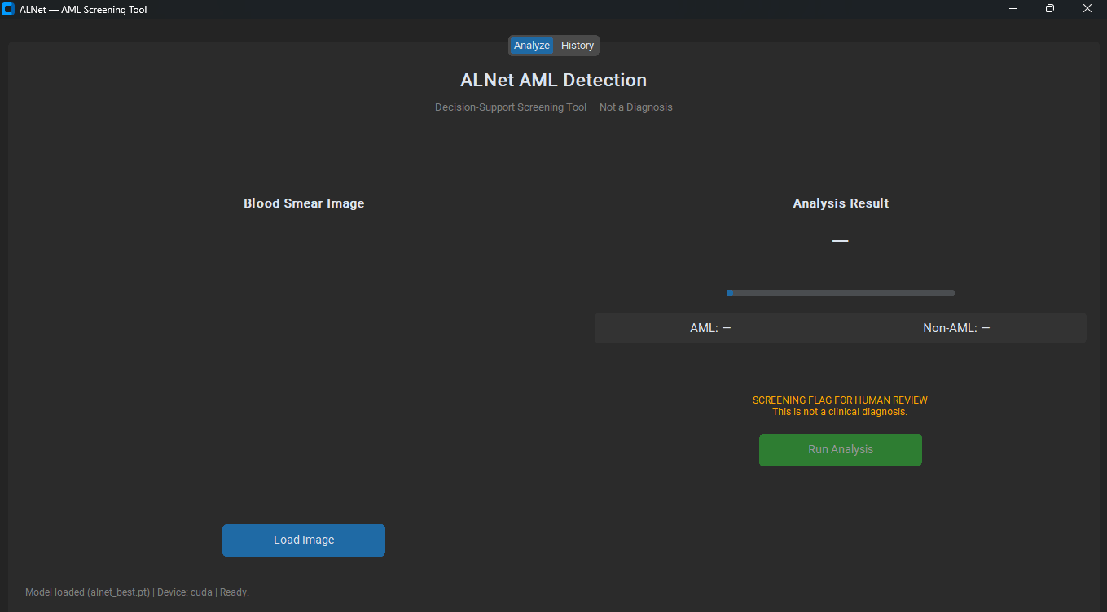
Figure 6: ALNet Screening Tool — Main application interface showing the Analyze tab with image preview area, analysis controls, and the screening-flag disclaimer.
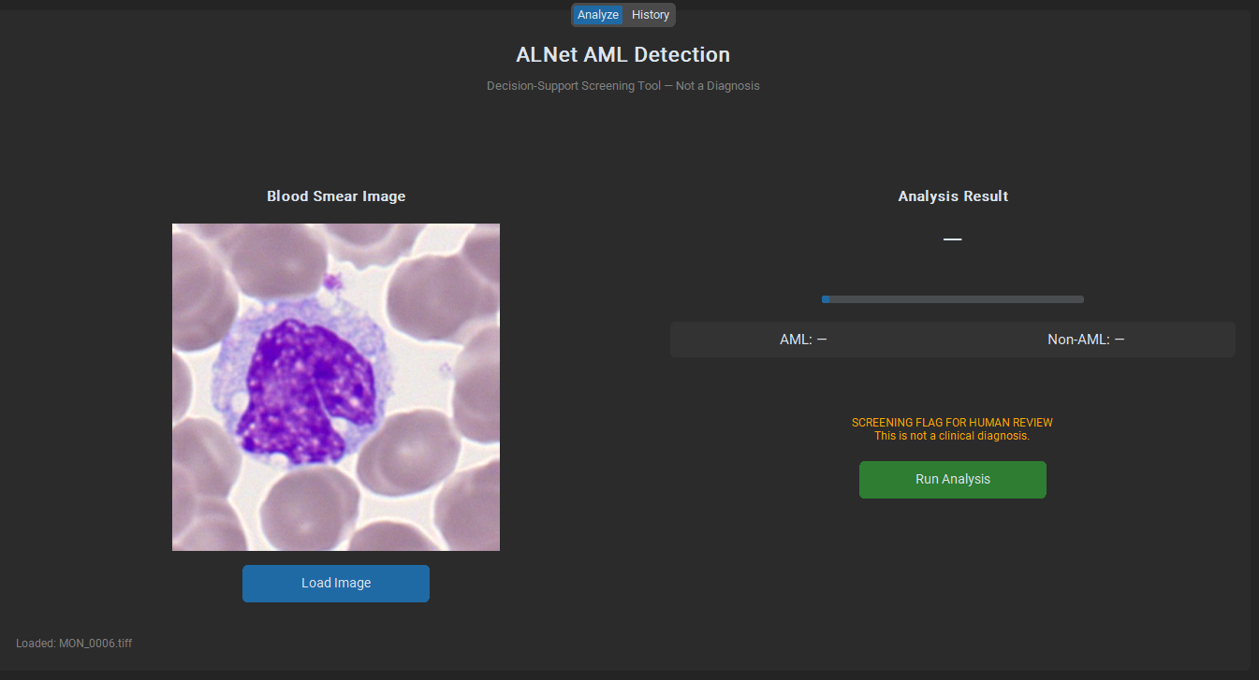
Figure 7: ALNet Screening Tool — Analysis result for a Non-AML (negative) case. The green result label and confidence breakdown confirm the model's normal classification, with the screening-flag disclaimer remaining visible.
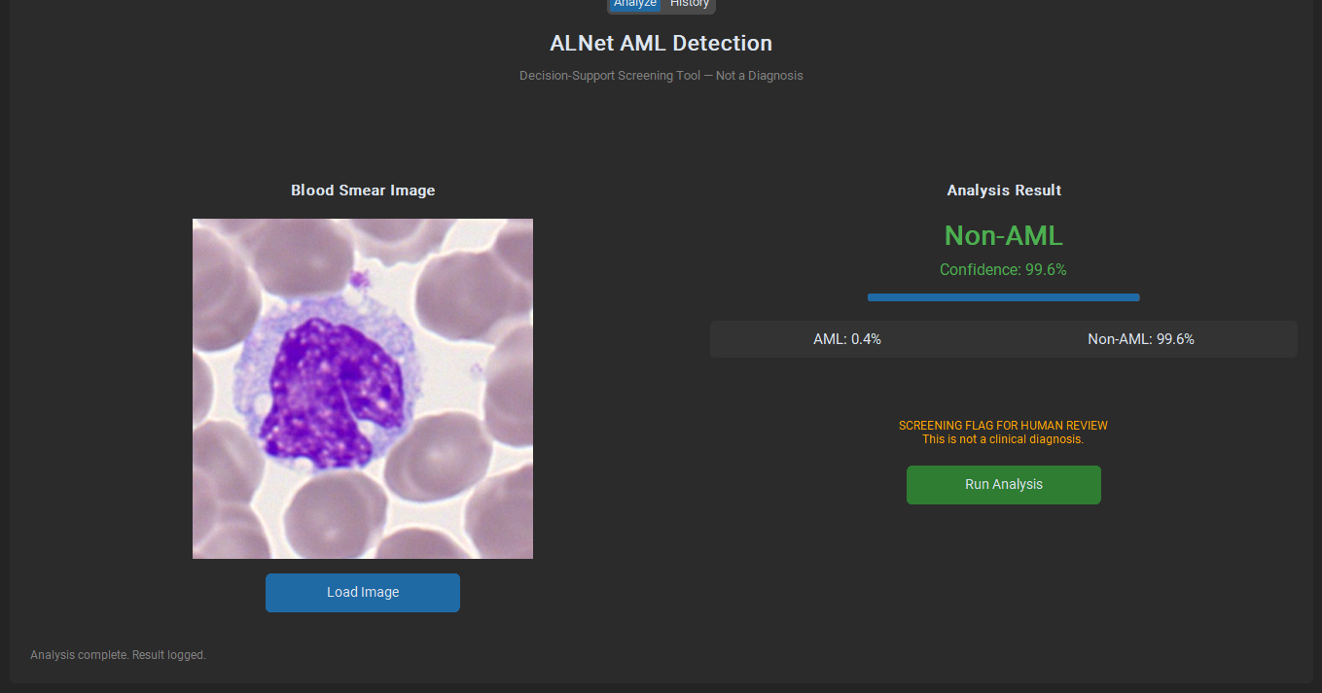
Figure 8: ALNet Screening Tool — Analysis result for an AML Detected (positive) case. The red warning label displays the screening flag with an explicit recommendation for expert hematopathologist review.

4.4.1 System Performance Characteristics
The following performance benchmarks were measured on the development and target hardware to assess the practical deployability of the ALNet system.
Table 4: System Performance Benchmarks
Metric | Value
Model Parameters | 27,393
Model Size on Disk (.pt) | 385 KB
Input Resolution | 224 x 224 x 3
Inference Time (GPU, RTX 3060 Ti) | < 50 ms per image
Inference Time (CPU, i5-12400F) | < 100 ms per image
Training Time per Epoch (GPU) | ~25 seconds
Executable Size (.exe) | ~2.5 GB (includes PyTorch + CUDA)
Memory Usage at Runtime | ~800 MB RAM

The model's compact size (385 KB on disk, 27,393 parameters) enables near-instantaneous inference on both GPU and CPU hardware. The standalone executable encapsulates the entire runtime environment, including PyTorch and all dependencies, allowing deployment on any Windows machine without requiring Python installation or library configuration. The application was tested to verify that a user with no prior AI or programming experience can load an image, run analysis, and interpret results within seconds.

4.5 Discussion
The results demonstrate that a lightweight deep learning architecture (27,393 parameters) can extract clinically meaningful features from blood smear images for AML screening. The AUC-ROC of 0.9675 shows that ALNet successfully learns to distinguish between AML and non-AML cellular morphology, even with severely limited positive training data. The model's computational efficiency — requiring only ~25 seconds per training epoch on a consumer-grade GPU — validates the design goal of creating a model suitable for deployment in resource-constrained settings.
However, the sensitivity of 50% represents a significant limitation. With 5 false negatives out of 10 AML test cases, the current model is not suitable for autonomous clinical deployment. The primary cause is the small positive sample size (48 training images), which limits the model's exposure to the full range of myeloblast morphological presentations. Additionally, the AML positive class was constructed by merging monoblasts and myeloblasts, which may have different morphological features that a model trained on only 48 examples cannot fully disentangle. The weighted focal loss and balanced batch sampling successfully prevented the model from degenerating into a majority-class predictor (which would achieve 98.7% accuracy by always predicting 'negative'), but could not fully compensate for the fundamental data limitation.
The threshold analysis (Figure 5) shows that adjusting the classification threshold does not significantly improve recall — the optimal threshold of 0.68 only marginally increases the F1-score from 0.3846 to 0.4545 without changing recall. This confirms that the limitation is in the model's confidence calibration for borderline AML cases, not in the decision threshold selection.
From a systems perspective, the ALNet implementation demonstrates strong deployment readiness for resource-constrained settings. The model's 27,393 parameters result in a 385 KB on-disk footprint, and inference completes in under 50 ms on GPU and under 100 ms on CPU — well within acceptable latency for interactive screening workflows. The standalone executable (ALNet_Screening_Tool.exe) bundles all dependencies into a single file, eliminating installation barriers. The desktop application was tested with representative blood smear images and successfully produced predictions with transparent confidence scores, session logging, and the required screening-flag disclaimer visible on every result screen (see Figures 6—8 for application screenshots). This validates Objective 3 and answers Research Question 3 affirmatively: a user interface can be integrated into the model to support direct utilisability by laboratory technicians.

CHAPTER 5: CONCLUSION AND RECOMMENDATIONS

5.1 Achievement of Objectives
Objective 1: Develop and train a detection model based on ALNet architecture.
This objective was achieved. ALNet was successfully designed, implemented, and trained on the AML-Cytomorphology_LMU dataset extract. The model architecture follows the proposed design: two depthwise separable convolutional blocks with localized sparse attention, a transition pooling block, and a progressively reduced dense block. The model achieves 27,393 trainable parameters, making it suitable for deployment on standard hardware. Training was completed on an NVIDIA RTX 3060 Ti GPU with stable convergence and no overfitting.
Objective 2: Test and evaluate the performance of the model.
This objective was achieved. The model was rigorously evaluated on a held-out 15% test set using imbalance-robust metrics. ALNet achieved an AUC-ROC of 0.9675, demonstrating strong discriminative ability. The model's sensitivity (0.5) and F1-score (0.3846) reflect the inherent challenge of training with only 48 positive examples. These results provide an honest baseline demonstrating that the architecture works, while clearly indicating the need for larger training datasets.
Objective 3: Develop a user interface to support easy utilisability.
This objective was achieved. A fully functional desktop application was developed using CustomTkinter, providing an intuitive interface for loading blood smear images, automated preprocessing, real-time AML screening with confidence scores, and session logging. The application explicitly labels all results as screening flags for human review, consistent with the decision-support scope defined in Section 1.5. The application was prepared for standalone executable packaging using PyInstaller, enabling one-click deployment without requiring Python or dependency installation.

5.2 Answering the Research Questions
RQ1: Is it possible to develop and train an ALNet-based model on AML blood smear images?
Yes. ALNet was successfully implemented and trained, achieving stable convergence with a compact parameter count of 27,393. The model demonstrates meaningful feature learning as evidenced by an AUC-ROC of 0.9675.
RQ2: Can the trained ALNet-based model detect myeloblasts from unseen blood smear images?
Partially. The model's AUC-ROC of 0.9675 indicates strong discriminative capability. However, with sensitivity of 50%, it misses half of the AML cases in the test set. This is a training data limitation rather than an architectural failure — the model learns meaningful features but lacks sufficient positive examples for robust classification.
RQ3: Is it possible to integrate a user interface into the model to support direct utilisability?
Yes. The desktop application successfully integrates the trained model with a user-friendly interface, automated preprocessing, and transparent confidence-based predictions suitable for laboratory technician use.

5.3 Limitations
1. Extremely Limited Positive Training Data: With only 48 AML images in the training set, the model cannot capture the full morphological diversity of myeloblasts. This is the single most significant limitation of this study and directly causes the 50% false negative rate.
2. Dataset Extent: The study used a subset (5,125 images) of the full AML-Cytomorphology_LMU dataset (18,365 images). Access to the complete dataset, including a more balanced distribution of cell types, would improve model robustness.
3. Single Dataset Source: All images came from a single institution's dataset, potentially limiting generalization to different staining protocols, microscope configurations, and patient populations.
4. No Patient-Level Split: Due to anonymized filenames, the data split was at the image level rather than the patient level, which may introduce subtle data leakage if multiple cells from the same patient appear across splits.
5. Binary Classification Only: The model does not differentiate between AML subtypes, limiting its diagnostic utility for treatment planning.

5.4 Recommendations for Future Work
1. Expanded Dataset: Future work should incorporate the full AML-Cytomorphology_LMU dataset (18,365 images), which would increase positive training samples and improve recall substantially.
2. Multi-Institutional Data: Incorporating blood smear images from multiple laboratories and staining protocols would improve model robustness and generalization to real-world clinical settings.
3. Domain Adversarial Training: Implementing the domain adversarial training approach proposed in the literature review would help the model generalize across different staining and imaging conditions.
4. Multi-Class Classification: Extending ALNet to classify AML subtypes would increase clinical utility for treatment planning.
5. Prospective Clinical Validation: A prospective validation study in partnership with the Uganda Cancer Institute would provide real-world evidence of clinical utility and identify deployment challenges specific to LMIC settings.
6. Model Optimization: Exploring quantization and TensorFlow Lite conversion would further reduce the model's computational footprint for deployment on mobile or edge devices.

REFERENCES
[1] Dores, G. M., et al. (2012). Acute leukemia incidence and patient survival among children and adults in the United States, 2001-2007. Blood, 119(1), 34-43.
[2] Kansal, R. (2019). Classification of acute myeloid leukemia by the revised fourth edition WHO criteria. Human Pathology, 90, 80-96.
[3] Munroe, M., et al. (2025). Low survival in younger adults with AML in Tanzania. PLoS One, 20(9), e0332237.
[4] Matek, C., et al. (2019). A Single-cell Morphological Dataset of Leukocytes from AML Patients and Non-malignant Controls (AML-Cytomorphology_LMU). The Cancer Imaging Archive.
[5] Jabeen, K., et al. (2016). The Impact of Socioeconomic Factors on the Outcome of Childhood ALL Treatment in a LMIC. J. Pediatr. Hematol. Oncol., 38(8), 587-596.
[6] Blumenthal, D., & Patel, B. (2024). The Regulation of Clinical Artificial Intelligence. NEJM AI, 1(8).
[7] Hamet, P., & Tremblay, J. (2017). Artificial intelligence in medicine. Metabolism, 69, S36-S40.
[8] Haferlach, T., et al. (2005). Global approach to the diagnosis of leukemia using gene expression profiling. Blood, 106(4), 1189-1198.
[9] Gao, H., et al. (2024). ALNet: An adaptive channel attention network for accurate indoor visual localization. Expert Syst. Appl., 250, 123792.
[10] Abhishek, A., et al. (2022). Automated classification of acute leukemia using machine learning and deep learning techniques. Biomedical Signal Processing and Control, 72, 103341.
[11] Saeed, A., et al. (2022). A Deep Learning-Based Approach for the Diagnosis of ALL. Electronics, 11(19), 3168.
[12] Hameed, M., et al. (2025). Acute myeloid leukemia classification using ReLViT. Scientific Reports, 15(1), 32798.
[13] Nakisige, C., et al. (2023). Artificial intelligence and visual inspection in cervical cancer screening. Int. J. of Gynecological Cancer, 33(10), 1515-1521.
[14] Wu, B., et al. (2025). Global, regional and national epidemiology of acute myeloid leukemia (1990-2021). Annals of Medicine, 57(1).
[15] Shafik, W., et al. (2026). A systematic literature review on transparency and interpretability of AI models in healthcare. Health Technol.
[16] Kalinaki, K. (2025). Internet of Health Things (IoHT): An Exploration of Principles, Components, Architectures, Challenges. Taylor & Francis.

